[](http://www.bing.com/images/search?q=Cup+of+Water+Clip+Art&view=detailv2&&id=191790A49FAC728E12F8B7508B0944AAC7B13FC5&selectedIndex=5&ccid=NQ2FWXzk&simid=60799432175144190)***Maple Spring***

***Water Cup***

Vol. 54 No. 4

December 2020

MAPLE SPRING CHURCH OF THE BRETHREN HOLLSOPPLE PA 15935 814-479-7062



**Mission Moment**

Presented by the Missions and Service Commission

Highlighting missions that Maple Spring supports

**Missions you can support over the Holidays and beyond!**

While shopping online, you can also help to support **New Day**. A portion of your eligible purchase price (.5%) will go to New Day. Visit smile.amazon.com and sign in with your Amazon.com account information. Choose New Day Incorporated, Johnstown, PA as your charitable organization. Start shopping.

**St. Francis Sharing and Caring** is sponsoring a gift giving program for families of the Food Pantry. Families in need have completed gift ideas for their children. Anyone who would like to sponsor a family should contact Kim Showalter or Michelle Mock at 479-3131 or 479-2192.

**Camp Harmony** is having a Nut and Apricot Roll and Christmas Cookie Sale to support its ministry. Each Roll is $10. Deadline to order is December 14. Cookie flavors are Thumbprint, Chocolate Chip, Snickerdoodle, Snowball, Oatmeal, and Peanut Butter Blossoms. The cost is 1 dozen- $7, 2 dozen - $13, and 3 dozen - $18. Orders are due December 16. Rolls and cookies can be picked up at Camp on December 21 & 22 from 9-4 each day or be delivered to the church. Sign up on annex lobby bulletin board or call camp at 814-798-5885.

Also, to benefit its ministry, **Camp Harmony** is hosting a Harmony Light Fest! Enjoy a drive-thru celebration of Christmas on Dec. 4, 11, and 18 from 6:00-9:00 p.m. The cost is $5 per car. Afterwards visit Faith Hall for wagon rides, bonfires, concessions, visit with Santa, Christmas Village, and judge the lights!

Donations of non-perishable food items may be contributed for the **St. Francis Sharing & Caring** Food Pantry. Please place donations in the box in the annex lobby. Our suggested food pantry items are apple sauce and pancake mix.

The Food Pantry at **St. Francis Sharing and Caring** needs volunteers to check in clients, pack boxes, stock shelves, and load vehicles with groceries. If you are interested in volunteering for one 3-hour shift each month please contact Michelle Mock at 814-242-5829.

Our two missions in Honduras were devastated by a hurricane in November. To help through **Hogar de Ninos Enmanuel** send donations to Western PA District Church of the Brethren, Mission Program Flood Relief, 115 Spring Rd., Hollsopple, PA 15935 and for **Project Global Village** send to: Amigos de Honduras, P.O. Box 98293, Seattle, WA 98198-0293.

Shoes are collected year-round to benefit the orphanage (**Hogar de Ninos Enmanuel**) in Honduras. They receive proceeds from the sale of the shoes. A box is located in the annex lobby for shoe collection.

***Merry Christmas and Happy New Year!***

Our monthly newsletter **Water Cup**

distributed gratis to members and friends of the congregation to encourage vital Christian living and

to promote participation in the life and work of the Church.

We hope you find this issue of the **Water Cup** informative and helpful. We welcome your contributions and comments.

Published by:

**MAPLE SPRING**

**CHURCH OF THE BRETHREN**

**106 Spring Rd**

**Hollsopple, PA 15935**

**814- 479-7062**

**E-MAIL -** [**maplespringcob@atlanticbb.net**](mailto:maplespringcob@floodcity.net)

**Web Page** – maplespringcob.org

Sunday School…………..9:30 a.m.

Traditional Service……..10:35 a.m.

Pastor Chris Heinlein (814) 414-7902

Office Hours: Tuesday – Friday, 9am-12pm

Editor Telephone (814) 479-7062

Email [maplespringcob@atlanticbb.net](mailto:maplespringcob@atlanticbb.net)

Temporary Secretary Connie Martin

Church Office Hours

Monday - Friday. 9:00 a.m.-1:00 p.m.

Please have all bulletin announcements in by

11am on Thursdays

**WATER CUP DEADLINE FOR**

**January 2021**

December 20, 2020

***Mission Statement***

*The living water of Christ wells up*

*within us and overflows!*

*It is our mission to be obedient to Christ*

*by living in unity and with one another,*

*by discipling one another through the Holy Spirit*

*and by reaching out to our neighbors.***PRAYER PARTNERS THIS MONTH**

j0097247[1]

Deanna Fisher and Sally Kaufman

Marlin Mishler and Arbutus Blough

Connie Martin and Patty Shaffer

Arlene Stevens and Elsie Michael

Karen Nagyvathy and Diane Bridge

Molly Stultz and Christine Shroyer

Pat Koba and Jordan Shroyer

Nancy Gindlesperger and Bill & Sandy Watkins

*Pray for another… the effectual fervent prayer of a righteous man availeth much.*

*The* ***Walnut Grove CoB and Arbutus CoB*** *are our prayer partner churches for the year 2019. Let us at Maple Spring keep them in our prayers.*

**DECEMBER NURSERY SCHEDULE**

Provided care is not available, due to Covid-19. Parents are welcome to use the nursery, but must stay with their children.

_________________________________________

At the November 15 Council Meeting, it was decided that we will proceed with the Pastoral Candidate Weekend and all Christmas activities with a reminder to practice mask wearing and to social distance when possible. Please be aware that should attendance increase it may become difficult to social distance inside the church building which is why we are emphasizing the wearing of masks. Those who are uncomfortable worshipping inside the church building on Sunday mornings can listen to the service from their vehicle in the parking lot on FM 99.9 on the radio. Also, if you would like a bulletin or newsletter mailed to you or know someone who would like one, please call the church office. We ask God’s blessing on each of you as we continue to serve Him.

_______

The Price of altar flowers will be increasing to $40 starting January 1, 2021. The cost is for 2 vases.

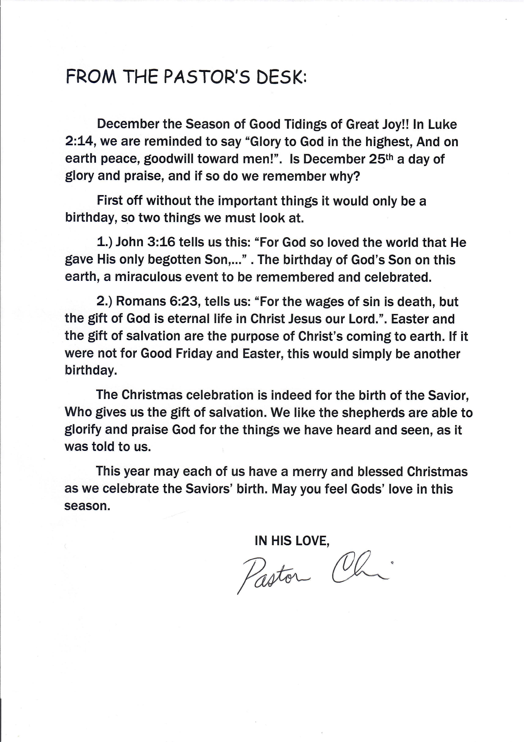

***Please remember the following who are actively*** ***serving our country...***

1st SGT George Adams Army

GUNRY SSGT Brock Hemminger Marines

SGT Adam Veres Army Specialist (WhitneyWeimer)

Jonathan Zanoni US Coast Guard (Cayla Roberts)

MAJOR Mark Bedrin Army (Katie McDonald)

SPECIALIST Sierra Alwine, Army

SrA Nathan Pahel - Air Force - (Annie Bridge)

Police Officer Matthew Bridge – Richland PD

AB Jenna A. Hauser – US Airforce

*A conscientious objector is one who is opposed to serving in the armed forces and/or bearing arms on the grounds of moral or religious principles. Conscientious objectors opposed to serving in the military are still required to register with the Selective Service System and will be placed in the Selective Service Alternative Service Program. Length of service in the program will equal the amount of time a man would have served in the military, usually 24 months.

**Prayer Flag**

We are thankful for those who do God’s work to protect us. Please pray for our peacekeepers. The Missions and Service Commission has a prayer flag displayed in support of active duty military personnel, 1st responders, EMS, firefighters, police officers, and conscientious objectors* presently serving from our congregation. If you have a loved you would like to add, please give the name, office, or type of duty, along with a picture to the church office. If you prefer not to submit a picture, we can simply post the name.

**Please also remember those from our Visitation List**

Gale Shipley 51 Akers Street

Johnstown, PA 15905

Cliff & Sally 960 Woodstown Hwy

Stuzman Hollsopple, PA 15935

Jim Moran 1056 Soap Hollow Rd  
 Hollsopple, PA 15935

Arlene Stevens Laurel View Village

Personal Care

1000 Vista Dr, Rm 526

Davidsville, PA 15928

Ruth Friedline PO Box 111/127 Maple Ln

Jennerstown, PA 15547

Iona Holder Country Manor Rm. 206

170 Phillips St.

Jerome, PA 15937

Don Stutzman Room 103B, 1404 Hay St

Berlin, PA 15530

Betty Shaffer Richland Woods

3324 Elton Rd

Johnstown, PA 15904

Phyllis Thomas Laurel View Village, Rm 522

2000 Cambridge Rd

Davidsville, PA 15928

_____________________________________________________________________________

Deacon Ministry

...Serving the Maple Spring Congregation

**“ THE GIFT ”**

Here we are at the end of another year! UNBELIEVABLE!!!

Now the Christmas rush begins. The shopping, baking, decorating… and on and on it goes. We all want to make this Christmas the very best for our loved ones. The time we spend preparing can be very stressful, but we know in the end it is worth all the effort.

What is your present for JESUS this year? Will you put a lot time and effort toward HIS gift? He doesn’t ask for anything, but our hearts and our sincere relationship with Him and that doesn’t cost anything!!

This year has been very unusual and very fearful for everyone. We must never forget that God is in Control ALWAYS! He knows what 2021 will be like for us. He wants to give the world a better life, but we must RETURN to Him with our whole being and our PRAYERS! Have you ever thought about what life would be like if God gave up on us the way we’ve taken Him out of our lives? I’m sure none of us wants that to happen! 2020 was a year we’ll never forget. We’re praying that 2021 will be a much better year, but only God knows what’s ahead.

The best gift we could ever give Him would be to tell God we’re sorry for the way we’ve been living and promise to give Him our whole life and our hearts. The MAJI brought gifts to honor the Baby Jesus, but the gift of our lives would mean even more to Him. It would put a smile on His face and all the angels in Heaven would rejoice because God’s children finally took up their crosses and returned to their first love!

Wouldn’t it mean more to you to know that you put a smile on God’s face? I’m sure that God in return would give you more blessings than you’ve ever been given before. Knowing what is to happen in the “End Times” would be easier to go through if you knew without a doubt that God will be holding your hand through it all because your 2020 Christmas gift to Jesus was… YOU!!

---Submitted by Carol Levernight

____________________________________________________________________________



**CHRISTMAS ACTIVITIES**

December 5th – 6:30 p.m. Meet & Greet Pastoral Candidate.

December 6th – Trial Sermon by Pastoral Candidate.

December 13th – Christmas fellowship immediately following the morning worship service. The Christian Education Commission will be serving the meal. Please note, due to COVID-19, we will **not** be bringing cookies to share. Dessert will be provided.

December 24th – 9:00 p.m. Christmas Eve service.

December 25th – MERRY CHRISTMAS!

December 27th – Bread & Cup Communion during the morning worship service.

**Activities are subject to change, due to COVID-19 restrictions.**

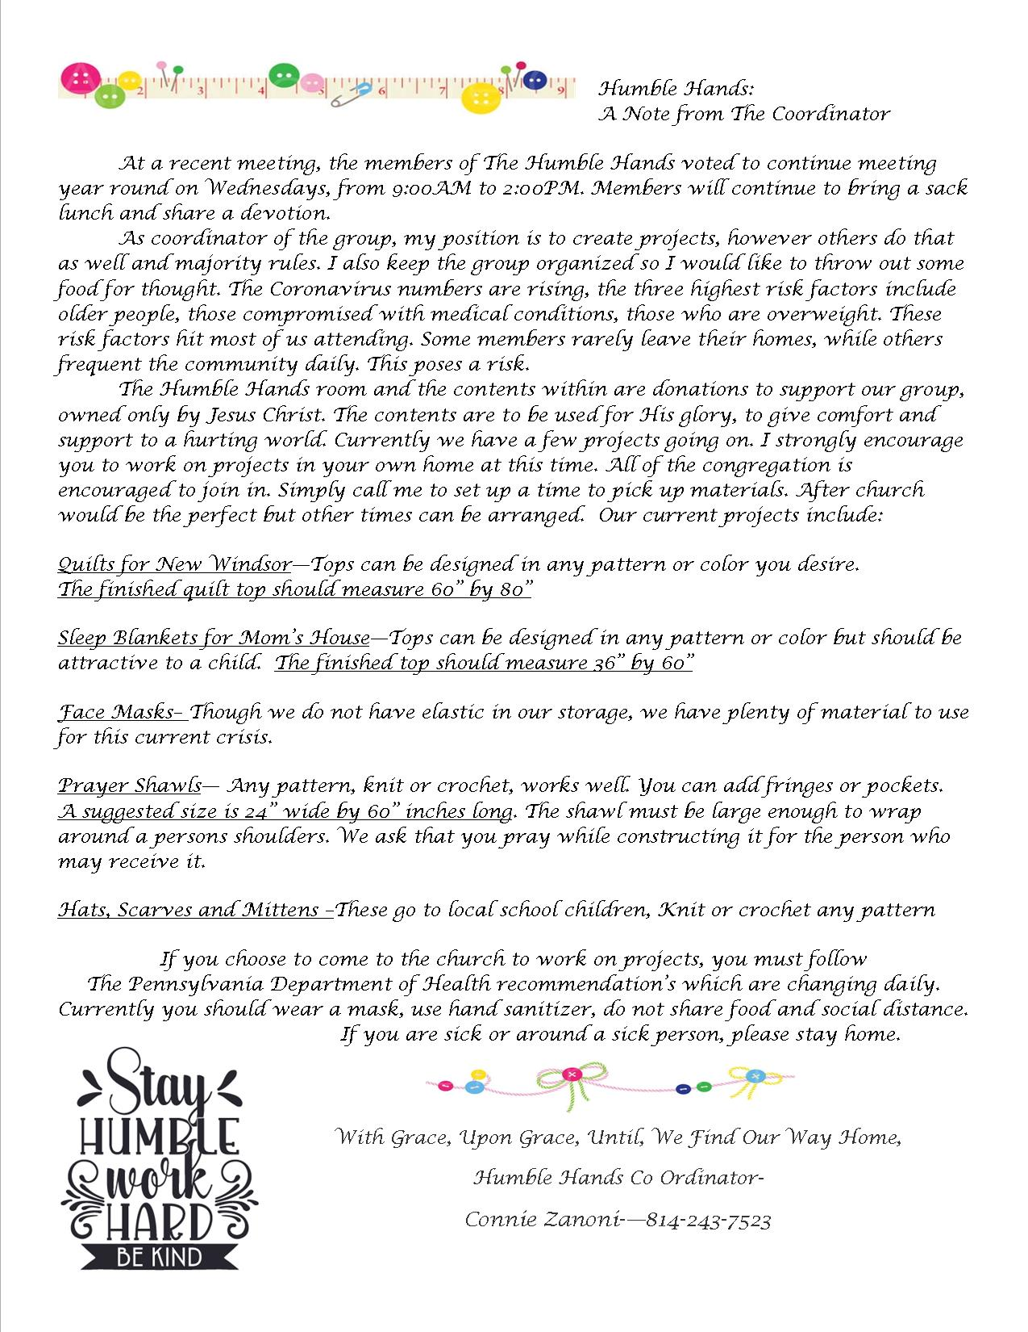



December 6th Birthdays

Arbutus Blough 84

Sally Stutzman 87

Meet & Greet with Pastoral Candidate

Owen Stevens 96

9am Prayer

Humble Hands

9 AM- Prayer

Sunday School 9:30

Worship 10:35 a.m.

Trial Sermon Pastoral Candidate

9am Prayer

Humble Hands

Humble Hands

Sunday School 9:30am

Worship 10:35 a.m.

Christmas Fellowship

Harold & Reta Alwine 65

H

9am Prayer

Humble Hands

MERRY

CHRISTMAS!

Sunday School 9:30 a.m.

Worship 10:35 a.m.

Gloria & Dale Holder 47

Christmas Eve Service 9 PM

Betty Shaffer 85

9am Prayer

Humble Hands

Sunday School 9:30 a.m.

Worship 10:35 a.m.

Communion

Iona Holder 93

Carol Levernight 74

9am Prayer

Humble Hands